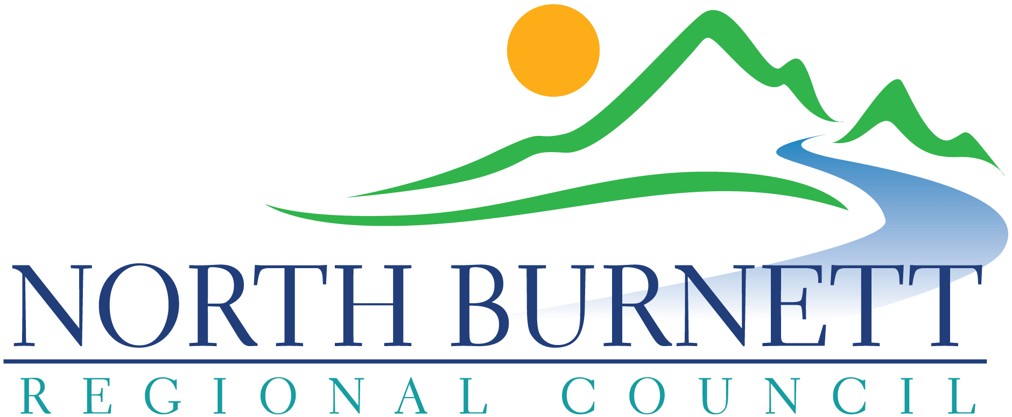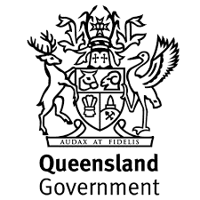
North Burnett Regional Council
Regional Arts Development Fund 2020/21 Program Guidelines

Purpose
- The Regional Arts Development Fund (RADF) is delivered as a partnership between the Queensland Government through Arts Queensland and eligible local councils across the state.
- RADF promotes the role and value of arts, culture and heritage as key drivers of diverse and inclusive communities and strong regions. RADF invests in local arts and cultural priorities, as determined by local communities, across Queensland.
- RADF is a flexible fund, enabling local councils to tailor RADF programs to suit the needs of their communities.

Objectives
RADF objectives are to support arts and cultural activities that:
- Provide public value for Queensland communities.
- Build local cultural capacity, cultural innovation and community pride.
- Deliver Queensland Government’s objectives for the community (see Appendix A)

Eligibility for RADF local grants
To be eligible to apply, you must be:
- A local professional artist, emerging professional artist, arts worker, arts and cultural group and/or organisation who is based in the North Burnett local government area. If based outside the area, you must demonstrate how the project will benefit arts and culture in the North Burnett and be auspiced by a local community group or organisation.
- Local schools, businesses and other types of non-arts groups are eligible to apply if they can demonstrate how the project will benefit arts and culture in the North Burnett
- A permanent resident or Australian citizen who has an Australian Business Number (ABN) or are sponsored by an incorporated organisation with an ABN.
- Unincorporated organisations sponsored by an incorporated body, based in the North
Burnett local government area.

2020-21 RADF Program Local Priorities
- Community Reconnection and Wellbeing
- Increasing Community Skills and Capacity in the Arts
- New Art Genres for the North Burnett
- Strengthening and Celebrating our Local Communities

RADF Applications that address the current local priorities can be submitted for either:
- Projects (various art genres)
- Professional Development
All forms and guidelines may be accessed via this link: www.northburnett.qld.gov.au/radf

Exclusions and Limitations
RADF will not fund
- Amateur arts activities EXCEPT for professional services to amateur arts activity. One of the main RADF aims is to develop professional artists in the regions. NOTE: Emerging professional artists are eligible for funding.
- Artists or arts-workers who do not have an Australian Business Number (ABN).
- Applicants who have NOT satisfactorily acquitted all previous RADF grants.
- Projects for which artists and art workers are paid less than the recommended rates.
- Activities that commence before Council approval is given. RADF should not be used as a top-up fund.
- Craft workshops – unless a professional artist or arts-worker is employed to work with a craft group to apply their skills in an innovative way to an arts development outcome.
- School arts activities EXCEPT where those activities form part of broader community cultural processes or are part of professional arts development.
- Framing or freight – only a small proportion of these costs can be covered as part of presentation costs for significant exhibitions.
- Competitions – they are prolific and could monopolise funds. The competitive environment does not necessarily nurture emerging artists, as there is generally only one winner
- Eisteddfods – they are essentially amateur competitions.
- Publishing costs – requests for grants to publish books should be directed to organisations that provide print-on-demand services. A small proportion of printing costs are eligible as part of the presentation costs for significant projects.
- Purchase of capital items eg equipment, buildings or vehicles. RADF gives artists and organisations opportunities for employment, professional development and a chance to practise their art. Buying capital items does not necessarily lead to these outcomes. EXCEPTION: Capital items can be funded only when they are included as part of a project application and when the RADF Committee considers the purchase integral to that project and where the item will remain available for community use.
- Recurrent funding for arts organisations – operational expenses are ineligible under RADF including wages for permanent staff and office expenses. However, local arts and cultural organisations that have regular community activities may apply for funding annually for different projects which have a project management component.
- Accredited study, training or university courses – Arts Queensland does not fund the primary training of artists, only their professional development once they are practising.
- Workshops with arts and cultural service organisations that are part of the organisations’ “core business” – Arts Queensland has already funded these organisations to deliver core services. Please call your cultural service organisations to find out what services they can offer you that are not “core business”.
- Murals – funding is available for murals from other government sources as part of anti-graffiti programs. RADF grants can only be allocated to murals that adhere to the RADF Principles, eligibility and program criteria.
- Projects involving any elements of cooking, creation or presentation of food.

Maximum limits for RADF local grants applications
- RADF funding will not fund 100% of project costs. Assessment will be made on value for money to the North Burnett and applicants are asked to demonstrate that attempts have been made to source funding from additional sources (eg a sponsor, other grant funding sources, applicant contributions (cash and/or in-kind), partnership contributions (cash and/or in-kind), community donations etc.
- Professional Development grants have a limit of $1,500 per application and may only be sought once per year. Applications to attend the MacGregor Summer or Winter Art Schools may be sought by applicants once every two years.

Application Process
The RADF Guidelines and a link to the Application Form for any current rounds of funding are available on Council’s website: www.northburnett.qld.gov.au/radf . For assistance to access this information online and fill in your application form, please visit your local Library to use one of the public access computers. If you have any further questions, please contact the RADF Liaison Officer via email NBRC admin@northburnett.qld.gov.au or by phoning 1300 696 272.

Step 1: Read through the RADF guidelines.
Step 2: Discuss your project or activity plans with RADF Liaison Officer (RLO)
Step 3: Complete the online RADF Application Form.
Step 4: Attach all required supporting documentation.
Step 5: Submit your application online prior to the close of the round.

RADF Rounds
The North Burnett Regional Council will offer 2 funding rounds per year with the option of one additional round if required. Dates for RADF rounds will be posted on Council’s website and publicised via Council’s social media feeds and noticeboards at least four weeks prior to close of a round.

Late Applications
As the closing dates for each round will be advertised 4 weeks in advance, extenuating circumstances only will be considered as a reason for a late application. Therefore, if a RADF application is submitted late (with due cause) but prior to the holding of the assessment meeting, the Committee can make a decision on whether or not the application can be considered within the round.

Assessment Process
The North Burnett Arts and Cultural Advisory Committee will meet within one fortnight of the close of round to assess all applications received. Recommendations are reported to the next General Meeting of the North Burnett Regional Council for approval. The process can take up to eight weeks before applicants are notified of the outcome and grant payments made.

Decisions are based on how the proposed project:
- meets the criteria for quality, reach, impact and viability in the North Burnett region;
- complies with the North Burnett Regional Council’s RADF guidelines and objectives; and
- aligns with the identified arts and cultural priorities of the North Burnett Regional Council.

Application Quality
All Applicants may seek feedback on their proposed application from the RADF Liaison Officer prior to submission. Assistance may also be sought from your local member representative on the North Burnett Arts and Cultural Advisory Committee. Contact details for the NBACAC Committee Members are available on the RADF page of Council’s website: www.northburnett.qld.gov.au/radf. Applications of a high quality are encouraged as the Assessing Committee has the right to reject applications that are not complete.

Acknowledgement of RADF
Public acknowledgement of the RADF program must be in accordance with Arts Queensland guidelines (see Schedule One attached). All RADF funded projects must be open for attendance by all interested people within the North Burnett Regional Council area. For successful acquittal, applicants must show evidence of public acknowledgement of the RADF program. To assist you, Council will supply you with the North Burnett Regional Council logo and State Government crest to include in all promotional materials; as well as make available a RADF banner which must be on prominent display at all RADF funded events. Book this banner through the RADF Liaison Officer.

Cancellation of a Project
If a project is cancelled, the full amount of funding is to be returned to the North Burnett Regional Council. Please make immediate contact with the RADF Liaison Officer if you anticipate any difficulties in delivering your project. The RADF Liaison Officer will discuss options to help with the successful delivery of your project. All changes to the originally funded application must have prior approval by the North Burnett Arts and Cultural Advisory Committee or Council.

Completing your Outcome Reports
RADF outcome reports show accountability for grant money usage. All recipients are required to submit an outcome report no later than eight weeks after the conclusion of the activity. An online Outcome Report template will be made available to all RADF grant recipients.

Helpful hints
- Remember to keep all copies of receipts to substantiate expenditure of the grant. Consider taking a photo of each receipt with your phone so that you have them available for the Outcome Report when the time comes.
- Take photos throughout your project delivery and supply at least three good photos in jpeg format with your outcome report.
- Have the RADF Banner erected and in a prominent place on the day/s of your event/s.
- Be sure to acknowledge RADF funding when speaking with media to promote your event/project. Also use the appropriate RADF Acknowledgement wording and logo in your promotional flyers.
- Keep links to any social media posts about your project for the Outcome Report.
- All information sent in for Outcome Reports is used by the North Burnett Regional Council to report back to Arts Queensland.
- Applicants must have their RADF grant successfully acquitted before being eligible to apply for future RADF funding.

APPENDIX A

Notes To Assist with RADF Application page 7 – Project Details - continued
Thorough planning must be demonstrated for all events/workshops/community art
projects to ensure maximum participation and community engagement with your project.

List key dates and milestones of your project planning process | Date to be completed by
- Gain proof of community support (cash and/or in-kind) for this project idea: signed petitions, letters from community groups, list of pre-bookings/participants | Please fill out these details on Page 7 - “Project Details – Continued” on the online Application Form.
- Set time frame of project – must not start within 8 weeks of submitting grant application.

- Confirm availability of artist / people needed in the project. Ask artist/s to complete RADF Eligibility Checklist
- Obtain quotes and costs for artist fees, travel and accommodation, venue hire, materials, production costs, printing, promotion, administration
- How will you promote the event? (Remember: all publicity must include RADF Acknowledgement as per Schedule One attached)
- Complete RADF Grant Application (www.northburnett.qld.gov.au/radf ). Please contact the RADF Liaison Officer if you need any assistance with this step.
- Attach all supporting documentation.
- Submit application online via SmartyGrants
- Put Media Plan into action, confirm bookings and preparations.

- Event / Project Delivery (book RADF Banner through the RADF Liaison Officer and collect from your local NBRC Library to display at event).
- Complete Online Outcome Report (8 weeks after project delivery)
Schedule One

Acknowledgment Guidelines for Grant Recipients
In accepting your RADF grant, you are required to acknowledge the financial assistance provided by the Queensland Government and the North Burnett Regional Council. By acknowledging this support, you are informing the community appropriately about how public funding is being spent.

You must acknowledge RADF funding in all publicity relating to funded activities through:
- Use of the Queensland Government and NBRC logos; and
- Use of the following acknowledgment statement:

The Regional Arts Development Fund is a partnership between the Queensland Government and North Burnett Regional Council to support local arts and culture in regional Queensland.

This includes all promotional materials such as brochures, posters, social media posts, conference programs, performance programs and invitations, signage at events, all media releases, television, radio and newspaper advertisements, speeches, websites, newsletters, annual reports and promotional videos.

Organisations or individuals receiving funding from the Regional Arts Development Fund are required to place the Queensland Government and Council logos in a prominent position on all material associated with the activity. On websites, a link should be placed to the home page of Arts Queensland’s website www.arts.qld.gov.au .

A special “stacked logo” incorporating both the North Burnett Regional Council logo and the State Government crest will be made available for successful RADF recipients to use in their acknowledgement of funding.

The Queensland Government logo must be no smaller in size and of no less visual significance than any other acknowledgment of assistance received for the project or funded outcome. Where RADF provides the majority of funding, the acknowledgment should precede all other acknowledgments.

Please note that you must supply a copy of all promotional materials and publications in acquitting your RADF funding to your Council. Failure to abide by these Guidelines may affect future funding decisions. In the event that breaches of the Guidelines come to the attention of Arts Queensland, the Deputy Director-General will write to you or your organisation and require a written response to explain the breach of the Acknowledgment Guidelines.

For enquiries, contact your local Council RADF Liaison Officer on 1300 696 272 or by email at admin@northburnett.qld.gov.au .

