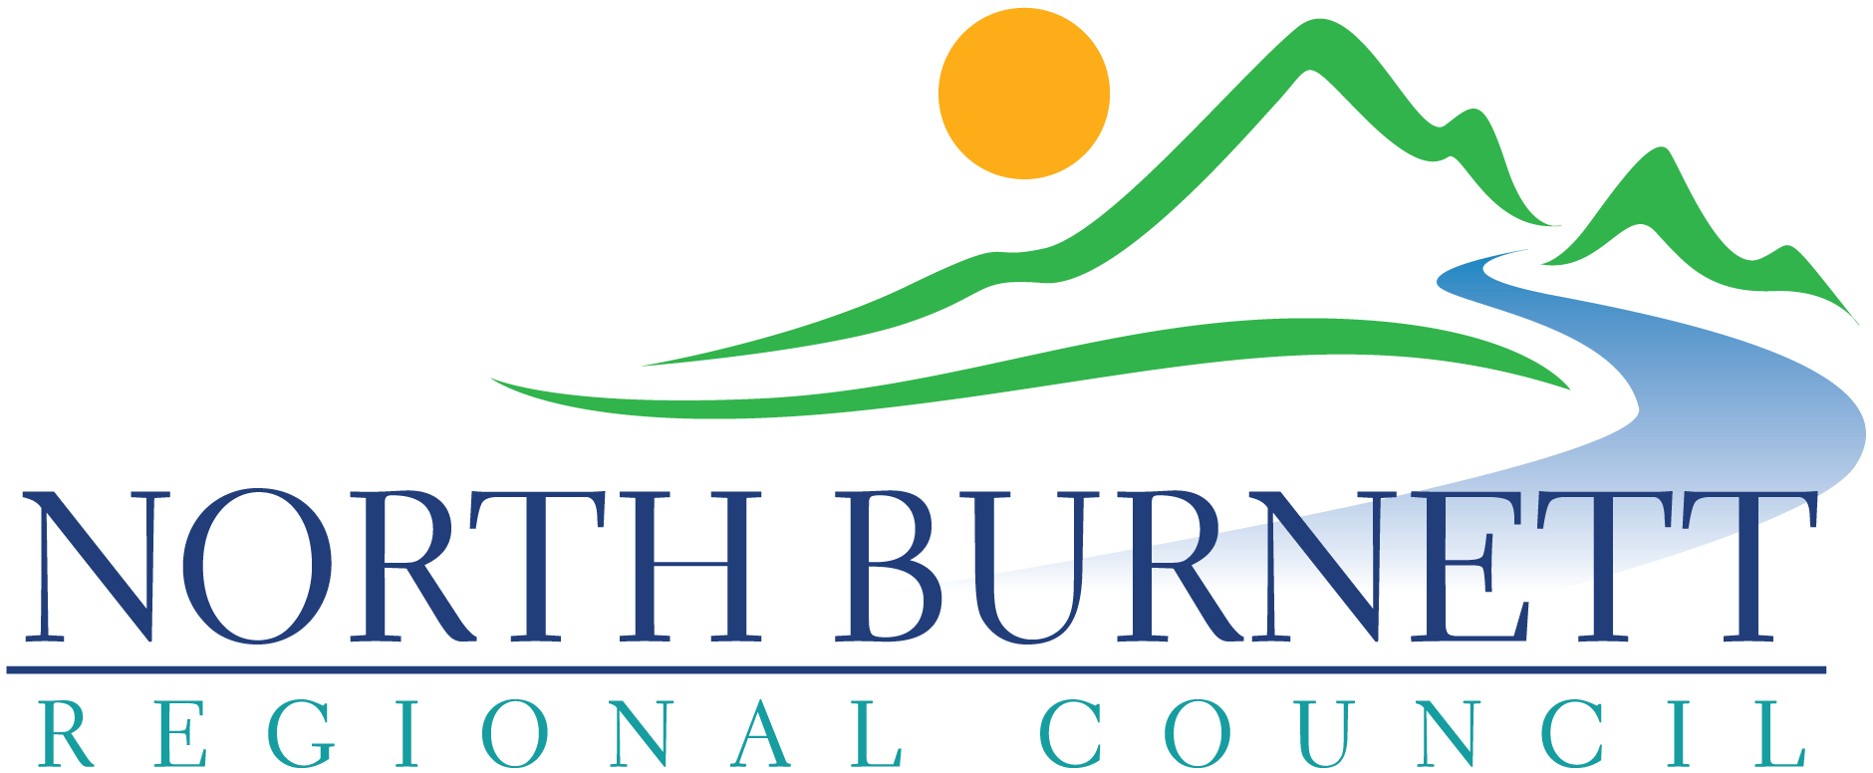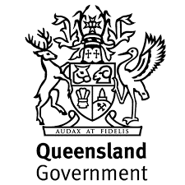

The purpose of the RADF Program is to support professional and emerging professional artists and arts workers to practice excellence in their art making for and with communities for mutual development.

This checklist has been developed to ensure that the status of artists as ‘professional’ and ‘emerging professional’ is clearly identified. Your responses to the questions below determine your status as an artist in regard to the RADF Program.

You need to tick *any three or more* of the artistic merits below to qualify as an artist with a professional or emerging professional status. Less than three artistic merits means you do not meet the eligibility requirements as a professional or emerging artist who can be funded by the RADF program. In this case, contact your RADF Liaison Officer to discuss alternative funding sources to support your arts project.

**Artist or Art Worker’s Name**: Click or tap here to enter text.

Please tick any of the artistic merits that apply to you:

My Australian Business Number (ABN) : Click or tap here to enter text.

I have professional arts and/or cultural qualifications

I have devoted significant time to arts/cultural practice

I have been recognised as a professional by my peers

I have held public exhibitions or given public performances (not as part of a competition)

I have work held in public collections

I have won important national and/or international prizes or awards

I have held public discussions and/or have had articles written about my work

I have been employed for my art/cultural skills and/or I am earning income from sales of artwork

I am an artist or cultural worker whose artistic or cultural knowledge has been recognised as professional by peers or the cultural community.

I am an artist or cultural worker whose artistic or cultural knowledge has developed through oral traditions

I am a member of a professional association (or associations) as a professional artist

Please specify: Name of Associations

Click or tap here to enter text.

**Regional Arts Development Fund**

**Eligibility Checklist**

**Professional and Emerging Artists**